**Project Report:**

**Appointment Reminder**

**By:**

**Nikhil Chadha  
379621  
Thapar Institute of Engineering and Technology**

**Introduction**

**The Appointment Reminder application is a web-based tool designed to help users manage and organize their appointments and reminders effectively. This project report provides an overview of the application, its features, and the development process.**

**Project Overview**

**The Appointment Reminder application aims to simplify the task of managing appointments and reminders for individuals and businesses. It provides a user-friendly interface and a set of features that enable users to create, view, and manage their appointments easily.**

**Features**

**The Appointment Reminder application offers the following features:**

* **User Registration and Login: Users can create an account and log in to access the application.**
* **Appointment Creation: Users can create new appointments by providing relevant details such as title, date, time, and description.**
* **Appointment Listing: Users can view a list of all their appointments, including the title, date, and time.**
* **Appointment Details: Users can click on an appointment to view its detailed information, including the description.**
* **Editing and Deleting Appointments: Users can edit or delete their appointments as needed.**
* **Reminder Notifications: Users receive reminders for their appointments via email or SMS.**
* **Time Zone Selection: Users can select their preferred time zone for accurate appointment scheduling.**

**Technologies Used**

**The Appointment Reminder application is developed using the following technologies:**

* **Programming Language: Python**
* **Web Framework: Django**
* **Front-end Development: HTML, CSS, JavaScript**
* **Database: MySQL**
* **Extra: Python Scripting language**

**Screenshots**

**User Registration:**

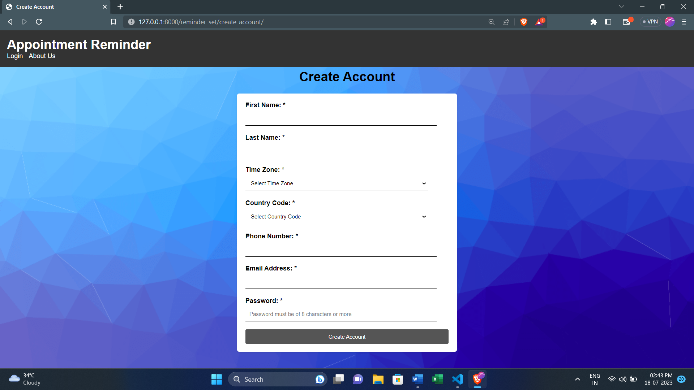

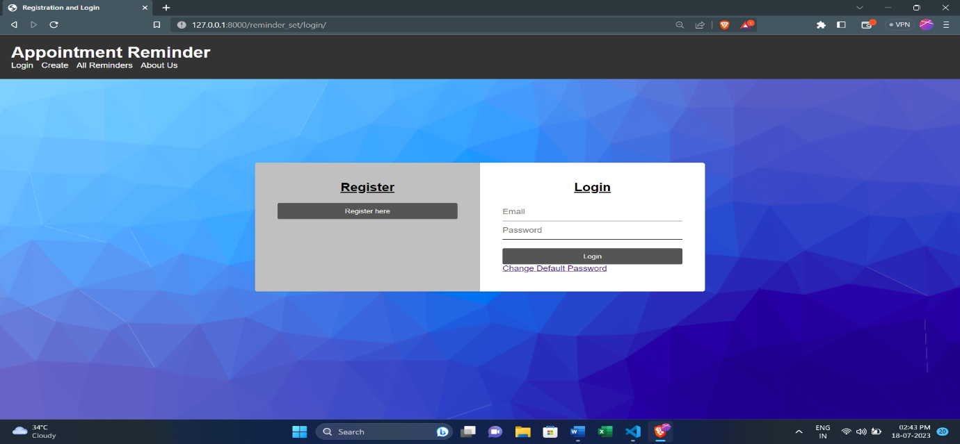**Login:**

**Appointment Creation:**

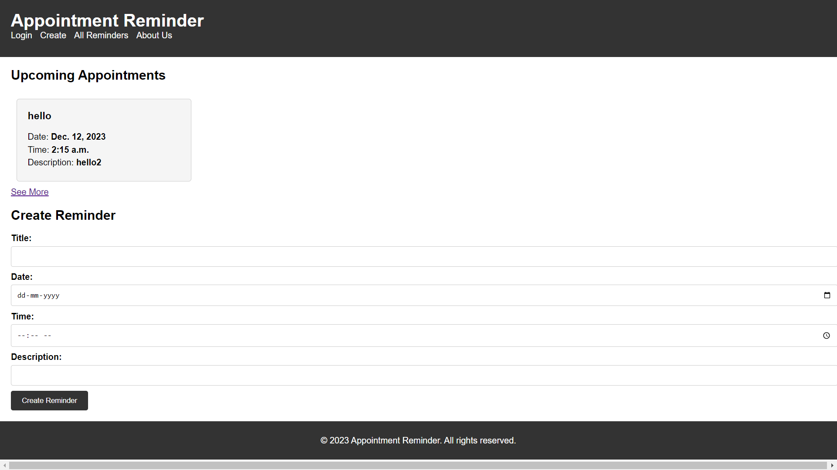

**Appointment Listing:**

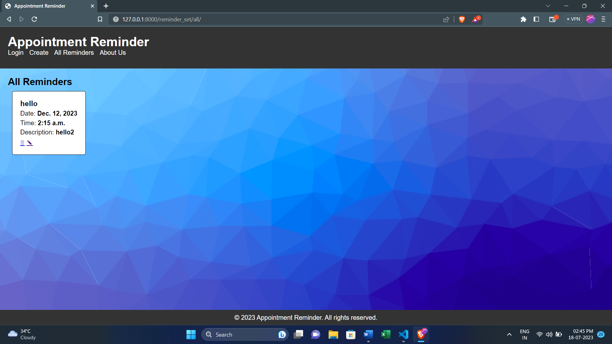

**AboutUs:  
  
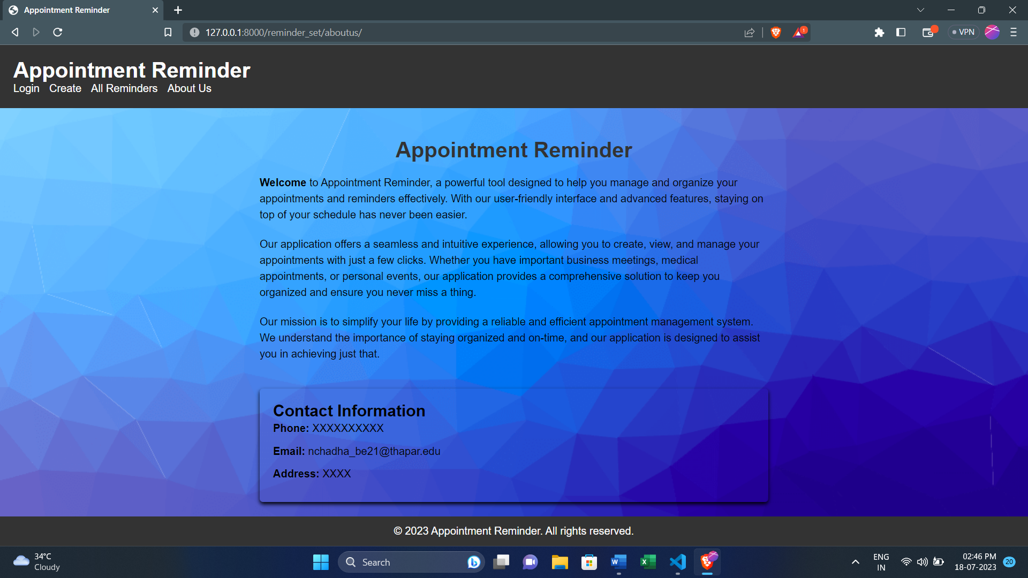**

**Steps To Run the Project-**

* **In settings.py enter the EMAIL_HOST_USER and enter the value of EMAIL_HOST_PASSWORD.**
* **In views.py change the email id same as the value of EMAIL_HOST_USER wherever required.**
* **In settings.py change the settings for the database.**
* **In views.py change the connection credentials in the views where database connection is being made.**

**To run the project:  
- Split the terminal in 2 parts.  
-In first run python manage.py runserver**

**-In second run python manage.py reminder_script  
  
  
Project Link -** [**https://github.com/nikhil697/AppointmentReminder-NotificationSender**](https://github.com/nikhil697/AppointmentReminder-NotificationSender)

**Conclusion**

**The Appointment Reminder application provides a convenient and efficient solution for managing appointments and reminders. It offers a user-friendly interface, essential features, and the flexibility to adapt to users' specific needs. By utilizing technologies such as Django, the application ensures robustness and scalability. Overall, the project successfully achieves its objectives of simplifying appointment management and improving productivity.**

**Future enhancements may include additional features such as recurring appointments, calendar integration, and integration with external notification services for enhanced reminder capabilities.**

**References:**

* [**www.google.com**](http://www.google.com)
* [**https://docs.djangoproject.com/en/4.2/**](https://docs.djangoproject.com/en/4.2/)
* [**https://docs.celeryq.dev/en/stable/django/first-steps-with-django.html**](https://docs.celeryq.dev/en/stable/django/first-steps-with-django.html)

**Appendix:**

* **MySQL:**

